**Project Planning Phase**

**Project Planning Template (Product Backlog, Sprint Planning, Stories, Story points)**

|  |  |
| --- | --- |
| Date | 11 November 2023 |
| Team ID | Team- 592183 |
| Project Name | Disease Prediction Using Machine Learning |
| Maximum Marks | 8 Marks |

**Product Backlog, Sprint Schedule, and Estimation (4 Marks)**

|  |  |  |  |  |  |  |
| --- | --- | --- | --- | --- | --- | --- |
| **Sprint** | **Functional**  **Requirement (Epic)** | **User Story**  **Number** | **User Story / Task** | **Story Points** | **Priority** | **Team**  **Members** |
| Sprint-1 | Registration | USN-1 | As a new user, I can register for the application by entering my email, password. | 2 | High |  |
| Sprint-1 | Login | USN-2 | As a user, I can login into the application by entering email & password | 1 | High |  |
| Sprint-2 | Accessibility | USN-3 | The platform is designed to be accessible to users with varying levels of health literacy, ensuring inclusivity. | 2 | High |  |
| Sprint-3 | Prediction | USN-4 | Upon submitting my health data, the machine learning model processes the information to predict potential diseases or health risks. The prediction is based on advanced algorithms that analyze patterns and correlations within the dataset. | 5 | High |  |
| Sprint-4 | Data collection | USN-5 | Preprocess the collected dataset by resizing images, normalizing pixel values, and splitting it into training and validation sets. | 2 | Medium |  |
| Sprint-4 | Data preprocessing | USN-6 | Explore and evaluate different machine learning ..architectures to select the most suitable for the  Disease prediction. | 3 | Medium |  |
| Sprint-4 | Training | USN-7 | Train the selected machine learning model using  The preprocessed dataset and monitor its  Performance on the validation set. | 6 | High |  |
| Sprint-4 | Testing | USN-8 | Conduct thorough testing of the model and user  Interface to identify and report any issues or  Bugs. | 2 | Medium |  |

**Project Tracker, Velocity & Burndown Chart: (4 Marks)**

|  |  |  |  |  |  |  |
| --- | --- | --- | --- | --- | --- | --- |
| **Sprint** | **Total Story**  **Points** | **Duration** | **Sprint Start Date** | **Sprint End Date**  **(Planned)** | **Story Points**  **Completed (as on Planned End Date)** | **Sprint Release Date**  **(Actual)** |
| Sprint-1 | 3 | 2 Days | 1 Nov 2023 | 2 Nov 2023 | 3 | 2 Nov 2023 |
| Sprint-2 | 2 | 3 Days | 3 Nov 2023 | 5 Nov 2023 | 2 | 5 Nov 2023 |
| Sprint-3 | 5 | 4 Days | 7 Nov 2023 | 10 Nov 2023 | 5 | 10 Nov 2023 |
| Sprint-4 | 13 | 4 Days | 11 Nov 2023 | 14 Nov 2023 | 13 | 14 Nov 2023 |

**Velocity:**

Imagine we have a 10-day sprint duration, and the velocity of the team is 20 (points per sprint). Let’s calculate the team’s average velocity (AV) per iteration unit (story points per day)



AV = 23/23 = 1

**Burndown Chart:**

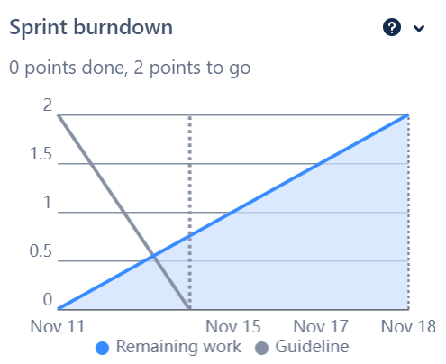

Board Section:

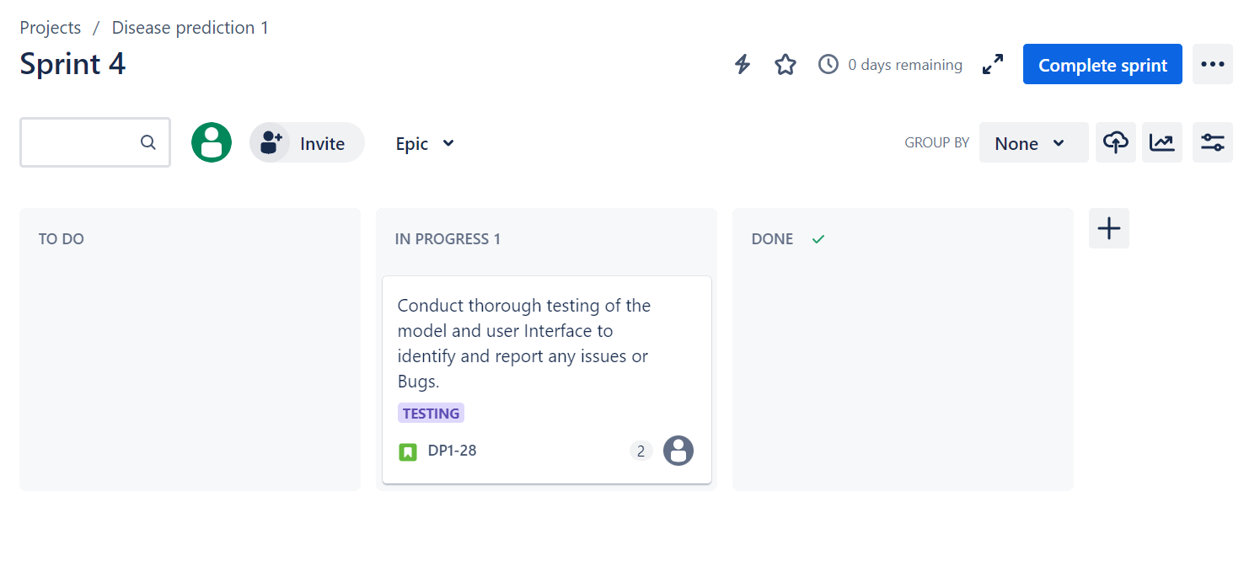

Backlog Section:

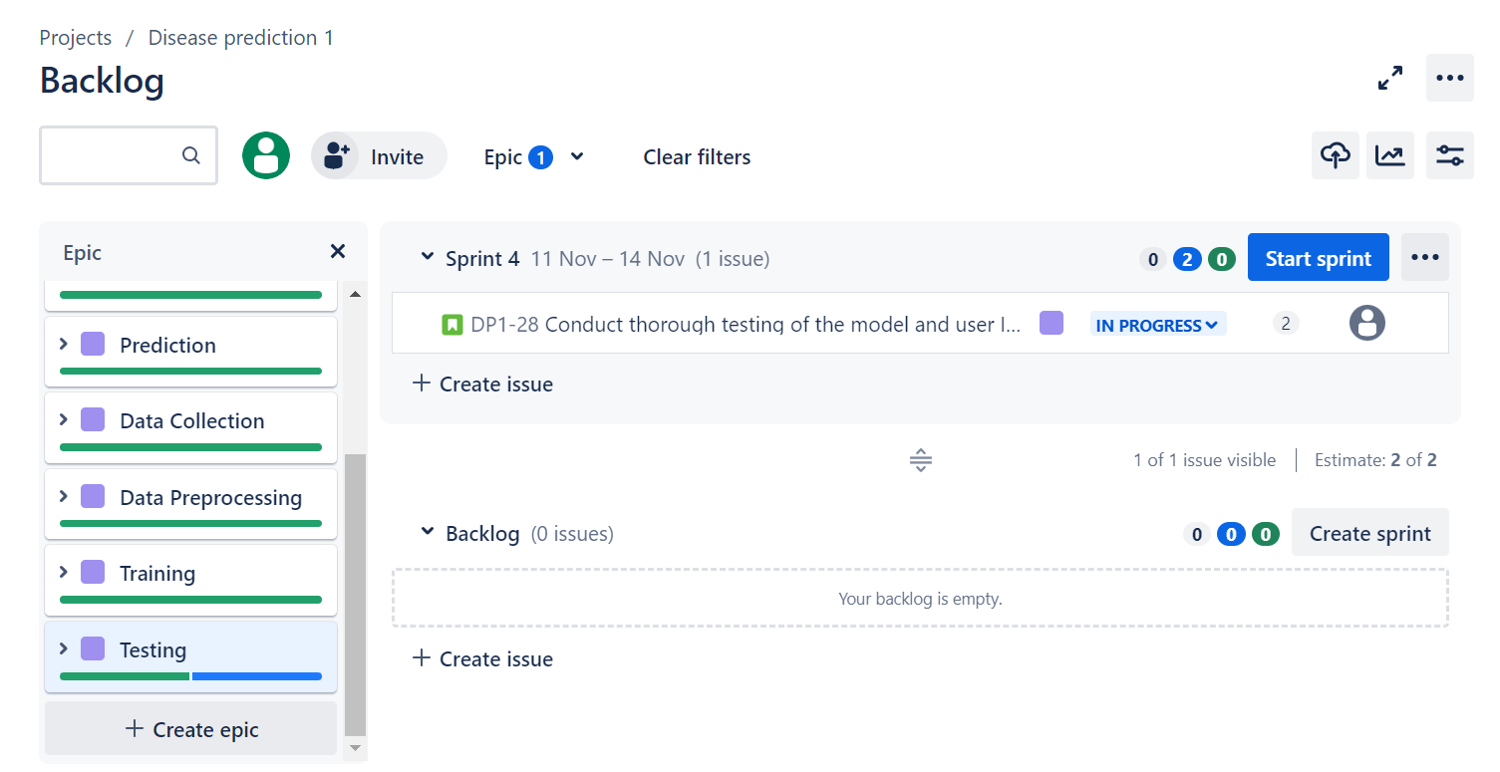

Timeline Section:

